**PROJECT SUMMARY REPORT**

**About The Project**

**blinkit Online Shopping Platform ‘Marketing Analysis’**

**Project Represented by: [Nilesh Yadav]**

Date: [22/08/2024]

**Project Overview:**

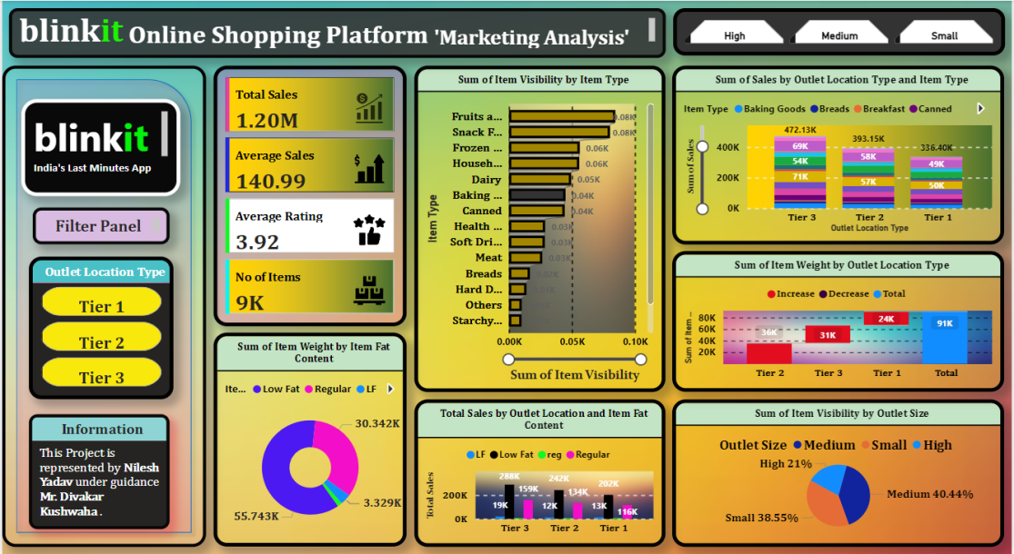

**- Objectives:**

* To develop **blinkit** online shopping marketing analysis dashboard which provide real-time insights. And in this project we are analysis online marketing data insights and analyze the profit, loss and average sales.

**Steps Followed :**

1. **Data Collection :** Collected blinkit online shopping data to serve as the foundation for a though analysis**.**
2. **Data Cleaning :** Ensured the data’s accuracy & reliability by carefully cleaning and validating it using Power query editor ,excel and MYSQL.
3. **Data Modeling :** Created a strong data model to established effective relationship between different data sets.
4. **Power Query Editor:** Used power query in Power BI to transform row data into meaningful insights.
5. **Dax Function (Data analysis Expression) :** Utilize dax to perform calculation and derive valuable insights from the data.
6. **Measure :** Developed customized measure and calculation to uncover trends and patterns.
7. **Charts :** Created visually engaging charts that clearly represent complex store data.
8. **Filters :** Applied filters and slicers to allow user to explore data on specific area.

**Useful Insights.**

* Overall revenue is **1.20 Million**
* Average sales **140.99 .**
* Average rating **3.92 .**
* Number of items **9 Thousand.**
* Outlet location Tier 2 are contribution more in revenue **65560.63** than tier 1 **23979.9** and tier 3 **(31235.00**) .
* Item fat content in low fat content are contributing to **61.41 %** of overall order.
* Fruit and vegetable are covered **84.81 %** overall items.

**Recommendation :**

**1. Sales Dashboard:**

* + Track daily sales, revenue, and profit margins
  + Analyze sales trends by region, product category, and time
  + Visualize top-selling products and customer segments

**2. Delivery Performance:**

* + Monitor delivery times, delays, and success rates
  + Identify bottlenecks in the delivery process
  + Compare performance across different regions and courier services

**3. Customer Insights:**

* + Examine customer demographics, behavior, and preferences
  + Analyze customer retention rates and churn
  + Visualize customer feedback and sentiment analysis.

**5. Marketing Effectiveness:**

* + - Measure campaign ROI, conversion rates, and customer acquisition costs
    - Analyze customer engagement metrics (e.g., website traffic, social media)
    - Visualize customer journey mapping and funnel analysis.